

**AMERICAN INTERNATIONAL UNIVERSITY-BANGLADESH (AIUB)**

Faculty of Engineering

Bachelor of Science in Electrical and Electronic Engineering (EEE) BAE 2101: Computer Aided Design and Drafting

**Experiment # 05:** Introducing with Electrical Symbols used for Electrical Circuit Design and drawing some Electrical Circuits using AutoCAD**.**

**Objective:** To familiarize students with Electrical Symbols used for Electrical Circuit Design and draw some Electrical Circuits using AutoCAD software.

**List of Electrical Symbols**

Direct Current Alternating Current

Resistor

Non-reactive Resistor

Impedance

Inductor Winding Capacitor

Earth

Line or cable:

existing

planned Underground Cable

**ELECTRICAL CIRCUIT DESIGN**

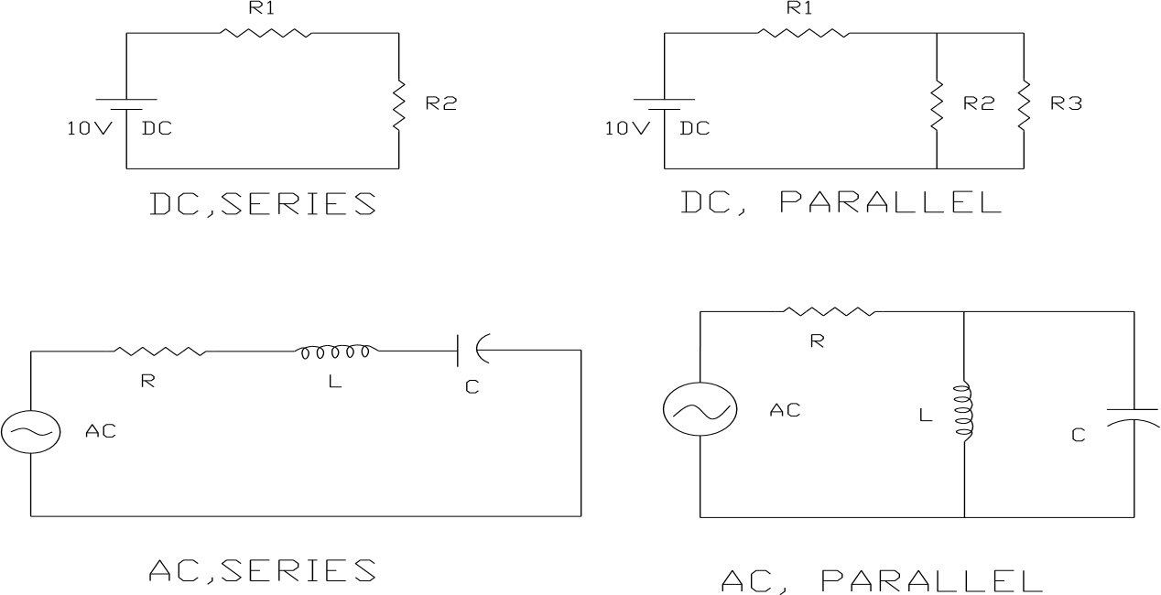

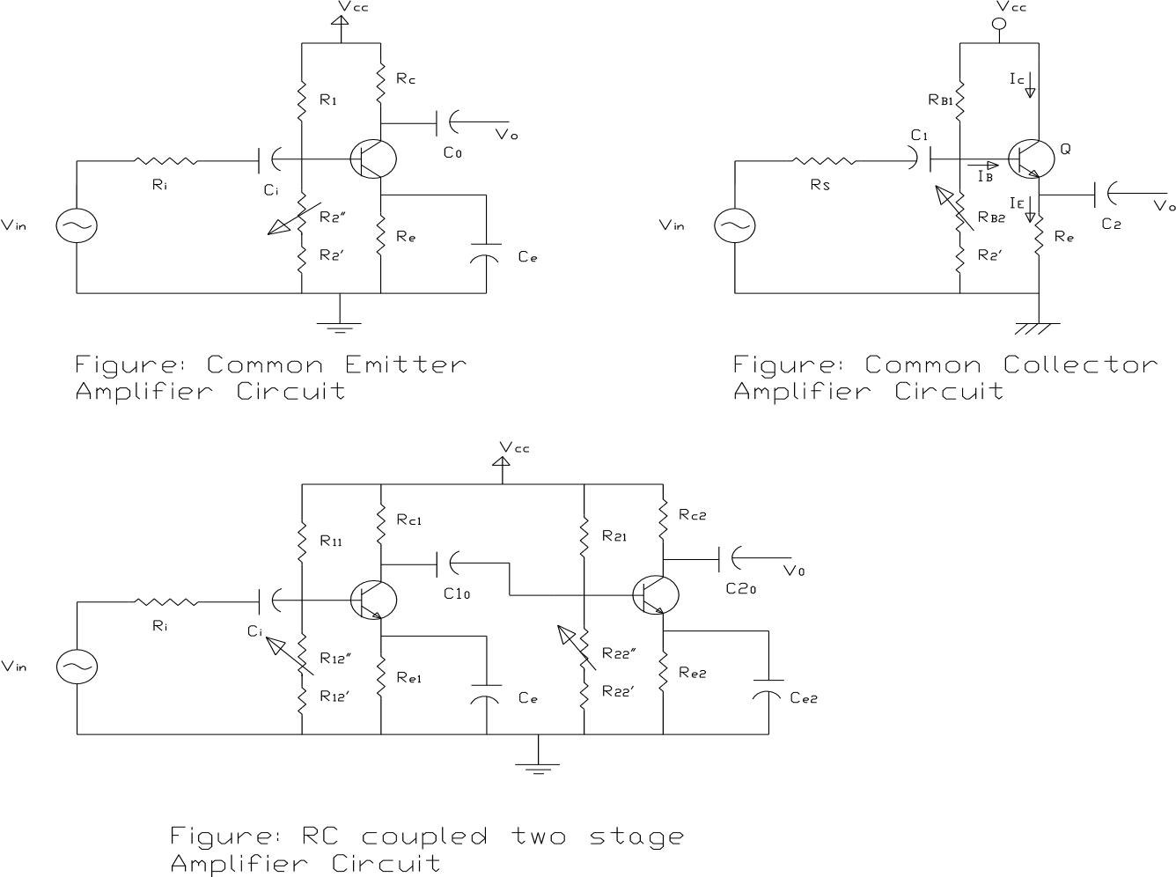

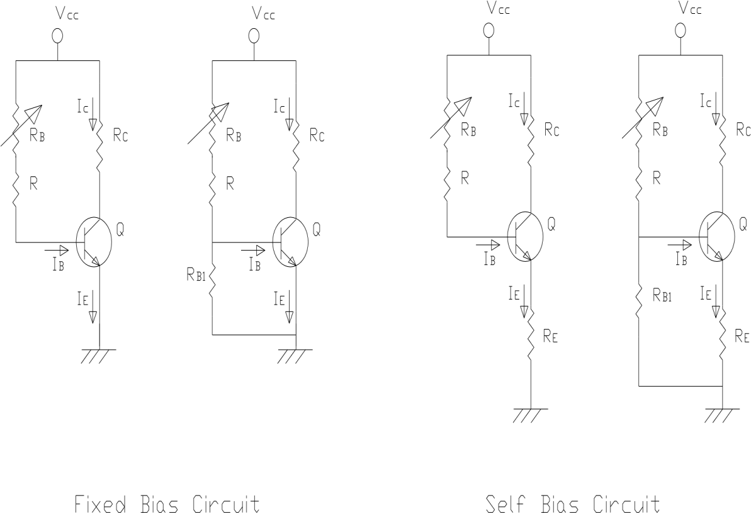

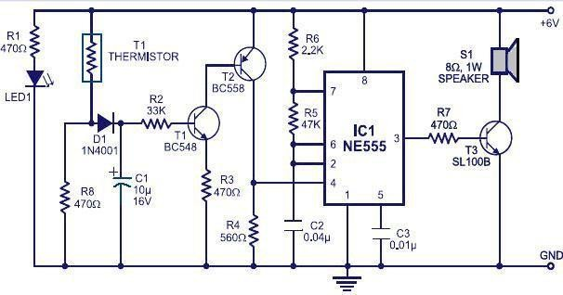

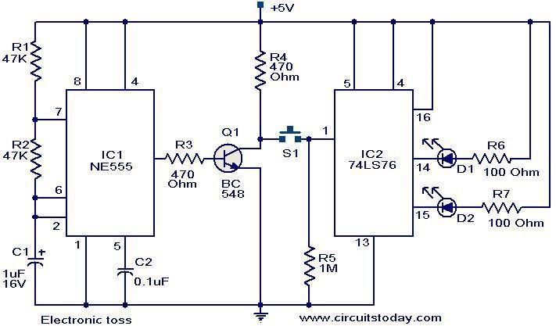

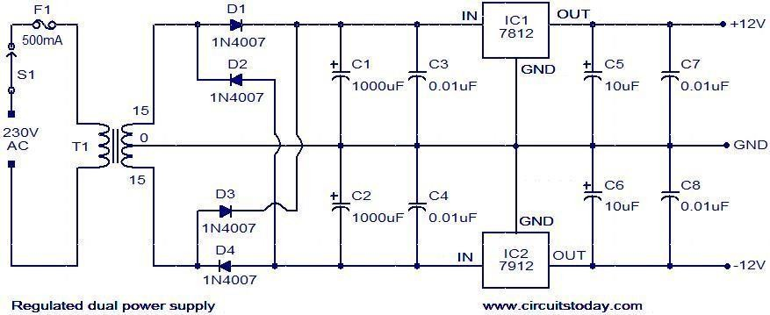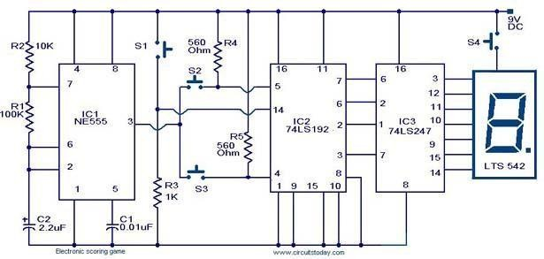

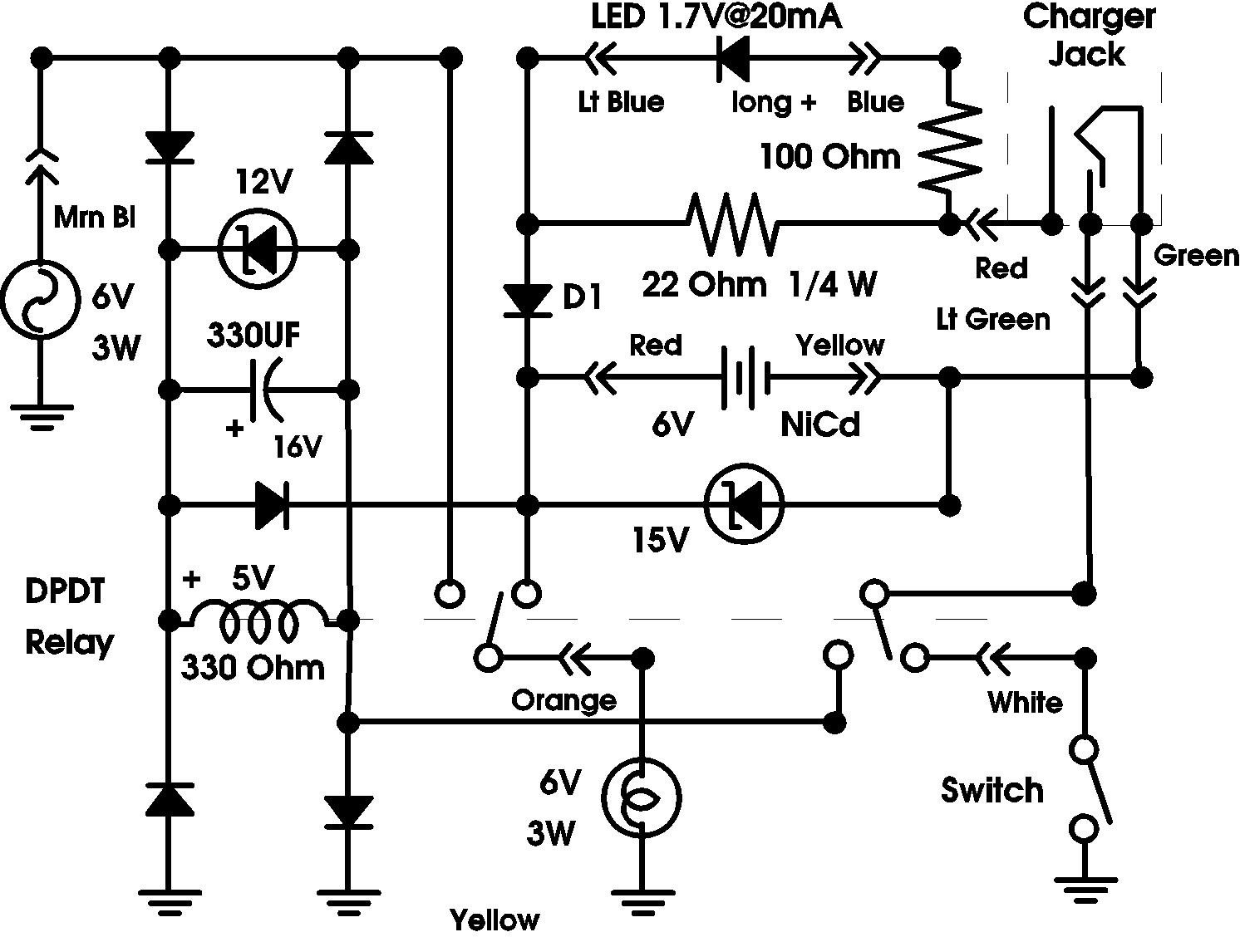

**References:**

1. Kristen S. Kurland, “AutoCAD 2004, 2D Training Manual”.
2. Bob McFarlane, “Beginning AutoCAD 2004”
3. David Byrnes and Mark Middlebrook, “AutoCAD 2007 For Dummies”.